MATLAB Programming & Simulation Attachment
Author: Chinmay Vilas Samak (Student, B.Tech. Mechatronics Engineering, RA1711018010102) Course: Fundamentals of Robotics (15MH301)
1. Homogenous Transformations 1
2. Forward Kinematic Model of KUKA KR5 Sixx R650 Manipulator 2
3. Kinematic Model of 1 DOF Beam Tilt Mechanism 4

1. Homogenous Transformations
fprintf('-----------------------------------------------------------------\n');
fprintf('1. Homogenous Transformations\n');
fprintf('-----------------------------------------------------------------\n');
% Frame Definition & Transformations
A = trotx(0) % Definition of frame {A}
T1 = transl(3,2,1); % Translation along x,y,z axes by 3,2,1 units. Yields 4x4 homogeneous transformation matrix with zero rotation.
T2 = trotx(60); % Rotation along x-axis by 60 degrees. Yields 4x4 homogeneous transformation matrix with zero translation.
B1 = T1*T2 % Frame {B} case 1
B2 = T2*T1 % Frame {B} case 2
% Comparing the Transformations
if B1 == B2
fprintf("Both Homogeneous Transformation Matrices Are Same.\n");
else
fprintf("Both Homogeneous Transformation Matrices Are NOT Same.\n");
end
% Frame Visualization
Bounds = [-1 5 -1 3 -1 3.5]; % Axis bounds [xmin xmax ymin ymax zmin zmax]
figure('Name','Frame Visualization','NumberTitle','off','windowState','Maximized');
trplot(A, 'frame', 'A', 'axis', Bounds, 'rgb', 'arrow'); % Plot frame {A}
hold on;
tranimate(A, B1, 'frame', 'B_1', 'axis', Bounds, 'rgb', 'arrow'); % Animate frame {B} case 1
hold on;
tranimate(A, B2, 'frame', 'B_2', 'axis', Bounds, 'rgb', 'arrow'); % Animate frame {B} case 2
hold off;
-----------------------------------------------------------------
1. Homogenous Transformations
-----------------------------------------------------------------
A =
1 0 0 0
0 1 0 0
0 0 1 0
0 0 0 1
B1 =
1.0000 0 0 3.0000
0 0.5000 -0.8660 2.0000
0 0.8660 0.5000 1.0000
0 0 0 1.0000
B2 =
1.0000 0 0 3.0000
0 0.5000 -0.8660 0.1340
0 0.8660 0.5000 2.2321
0 0 0 1.0000
Both Homogeneous Transformation Matrices Are NOT Same.
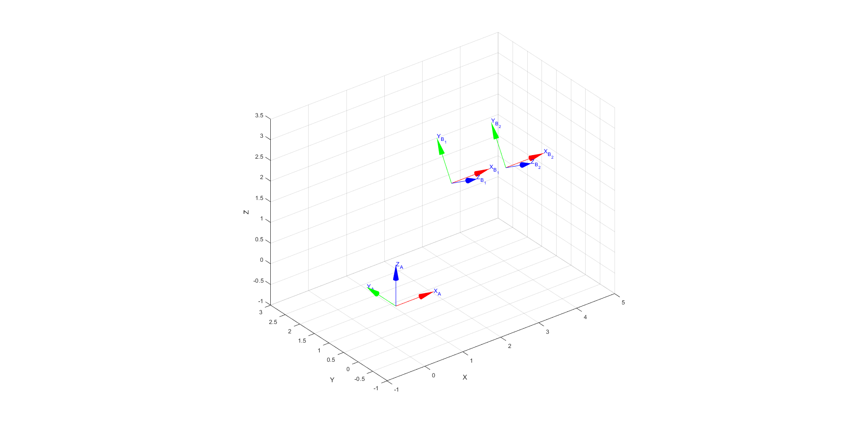

2. Forward Kinematic Model of KUKA KR5 Sixx R650 Manipulator
fprintf('-----------------------------------------------------------------\n');
fprintf('2. Forward Kinematic Model of KUKA KR5 Sixx R650 Manipulator\n');
fprintf('-----------------------------------------------------------------\n');
% Define DH Parameters
L(1) = Link([0 0.335 0.075 -pi/2]);
L(2) = Link([0 0 0.270 0]);
L(2).offset = -pi/2;
L(3) = Link([0 0 0.090 -pi/2]);
L(4) = Link([0 0.295 0 pi/2]);
L(5) = Link([0 0 0 -pi/2]);
L(6) = Link([0 0.080 0 0]);
% Define the Robot Objects
Robot = SerialLink(L, 'name', 'KUKA KR5 Sixx R650');
Animated_Robot = SerialLink(L, 'name', 'Animated KUKA KR5 Sixx R650'); % Define another robot object with different name because if the robot already exists then that same graphical model will be found and moved.
% Forward Kinematics
FKM = Robot.fkine([0 0 0 0 0 0]) % Forward Kinematic Model (FKM) for home position
% Robot Visualization
figure('NumberTitle', 'off', 'Name', 'Robot Visualization','windowState','Maximized');
Robot.plot([0 0 0 0 0 0]); % Home position
% Define Joint Angle Variables
th1 = 0;
th2 = 0;
th3 = 0;
th4 = 0;
th5 = 0;
th6 = 0;
% Robot Animation
figure('NumberTitle', 'off', 'Name', 'Robot Animation','windowState','Maximized');
for i = 0:0.05:pi/2
th2 = i/2;
th3 = i/2;
Animated_Robot.plot([th1 th2 th3 th4 th5 th6]);
end
for i = pi/2:-0.05:0
th2 = i/2;
th3 = i/2;
Animated_Robot.plot([th1 th2 th3 th4 th5 th6]);
end
for i = 0:0.05:pi
th1 = i;
th2 = i/4;
th3 = i/4;
th4 = i/2;
th6 = -i/2;
Animated_Robot.plot([th1 th2 th3 th4 th5 th6]);
end
-----------------------------------------------------------------
2. Forward Kinematic Model of KUKA KR5 Sixx R650 Manipulator
-----------------------------------------------------------------
FKM =
0 0 1 0.45
0 -1 0 0
1 0 0 0.695
0 0 0 1
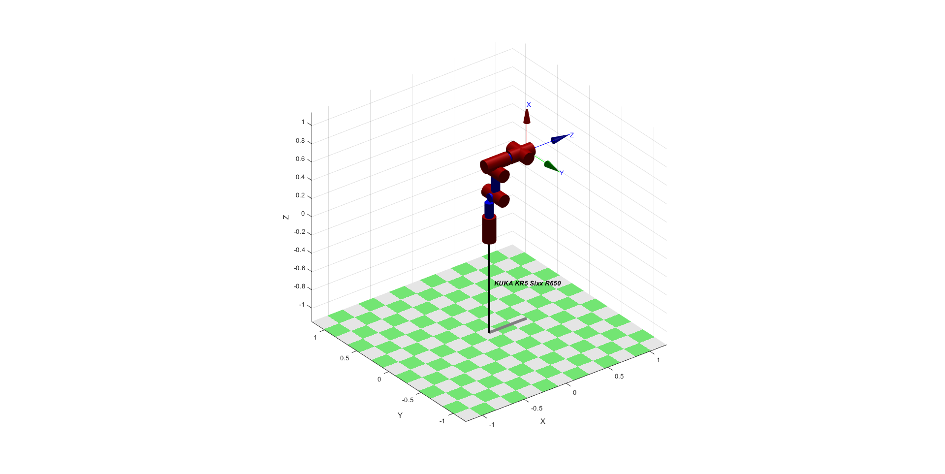
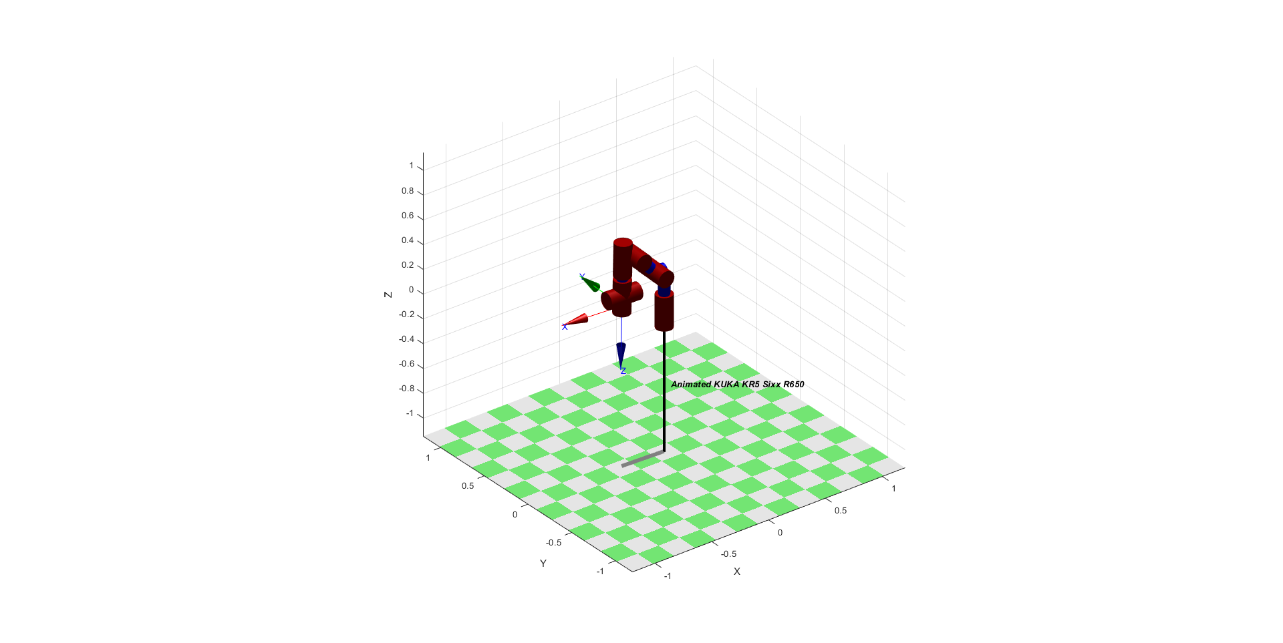

3. Kinematic Model of 1 DOF Beam Tilt Mechanism
fprintf('-----------------------------------------------------------------\n');
fprintf('3. Kinematic Model of 1 DOF Beam Tilt Mechanism\n');
fprintf('-----------------------------------------------------------------\n');
% Tilt Angle
input = inputdlg('Enter Tilt Angle in Degrees: '); % User input for tilt angle in degrees
theta_degrees = str2double(input); % Convert string input to numerical value
theta = deg2rad(theta_degrees); % Convert degrees to radians
fprintf('Tilt Angle: %0.4f degrees\n', theta_degrees);
if (theta_degrees >= -45 && theta_degrees <= 45) % Mechanical constraint
% Define Transformations
B0_T_P = [cos(theta) -sin(theta) 0 5; sin(theta) cos(theta) 0 11; 0 0 1 0; 0 0 0 1];
P_T_A0 = [1 0 0 -5; 0 1 0 0; 0 0 1 0; 0 0 0 1];
B0_T_A0 = B0_T_P * P_T_A0;
% Coordinates of Points A0 and B0
x_A0 = B0_T_A0(1,4);
y_A0 = B0_T_A0(2,4);
z_A0 = B0_T_A0(3,4);
x_B0 = 0;
y_B0 = 0;
z_B0 = 0;
% Compute the Actuator Lenghth
l = sqrt((x_A0 - x_B0)^2 + (y_A0 - y_B0)^2 + (z_A0 - z_B0)^2); % Euclidian distance between points
fprintf('Actuator Length: %0.4f units\n',l);
else
fprintf('The mechanical constraint is not satisfied!\nPlease enter tilt angle in range of [-45,45] degrees.\n');
end
-----------------------------------------------------------------
3. Kinematic Model of 1 DOF Beam Tilt Mechanism
-----------------------------------------------------------------
Tilt Angle: 30.0000 degrees
Actuator Length: 8.5264 units
Published with MATLAB® R2018a

